**3. Digital matte paint:**

**Step 1:** open a new photoshop file and get your all images ready.(Theme-doorway to afterlife)

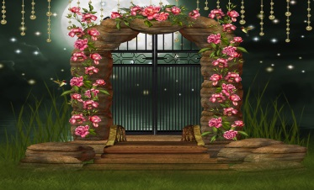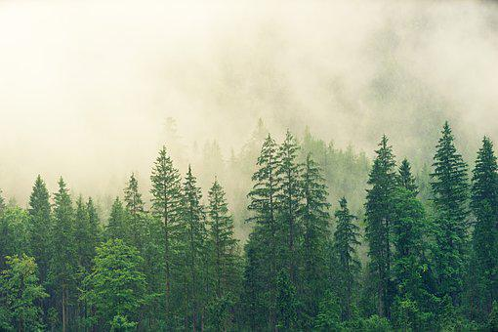

**Step 2:** Take the forest background and take blue BG and space BG and reduce their opacity till they look good.

**Step 3:** Now cut out the flower arch out of the image as a layer mask and move it on to the background layer.

**Step 4:**We already have a cloud png image so we put the cloud png in the flower arch and make multiple copies of it making it look good.

**Step 5:**Use hue and saturation to make it more appealing .

**Step 6:**Now cut out the bridge from the image and put it under the clouds and adjust few layers to make it complete.

**Step 7:** Adjust the opacity of clouds and background to blend them in the theme .

**Step 8:** Add a new layer and select layer kind to lighten and take a brush and with white as foreground colour draw few places which are to be brightened / glow and set foreground colour black to darken any few spots which aren’t exposed to light (Like under clouds etc).

**Final**